**Library Application Documentation**

**Development Tools : .net core ,entity framework code first,angular8.**

**First window is categories window as follows**

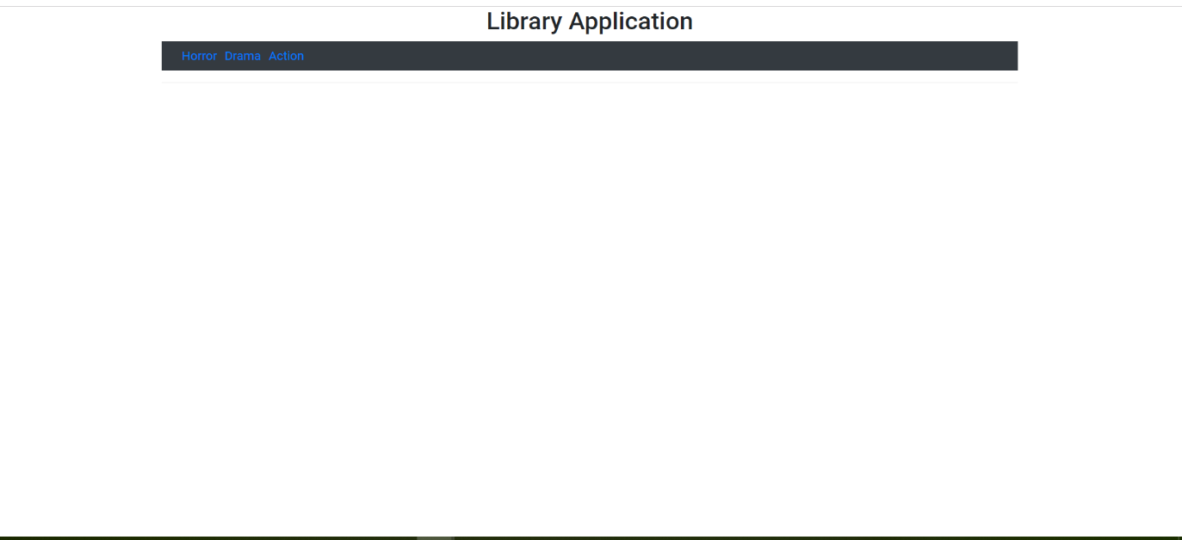

**You can select any category to load it’s books ,and load them in a new window**

**Like the following image.**

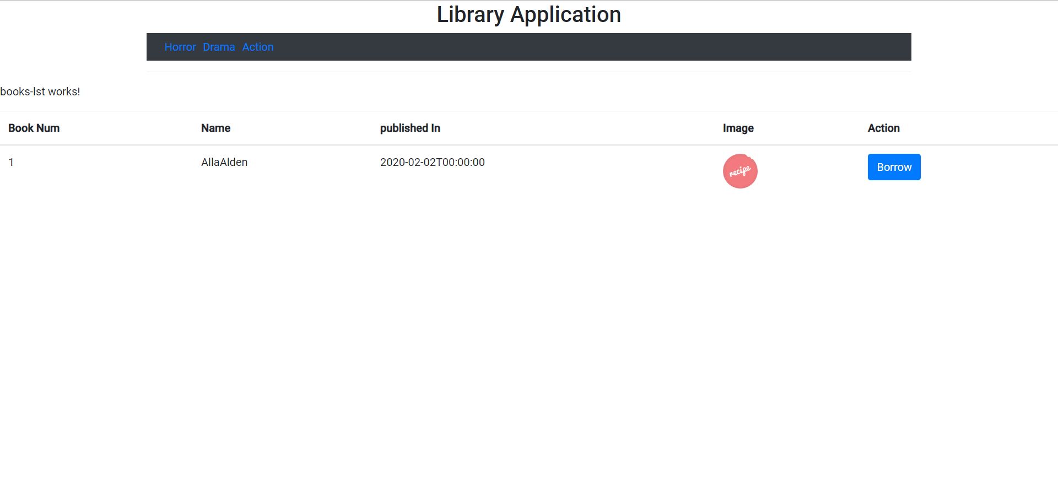

**To borrow a book you should click to the borrow button of that book,then the following window will be opened**

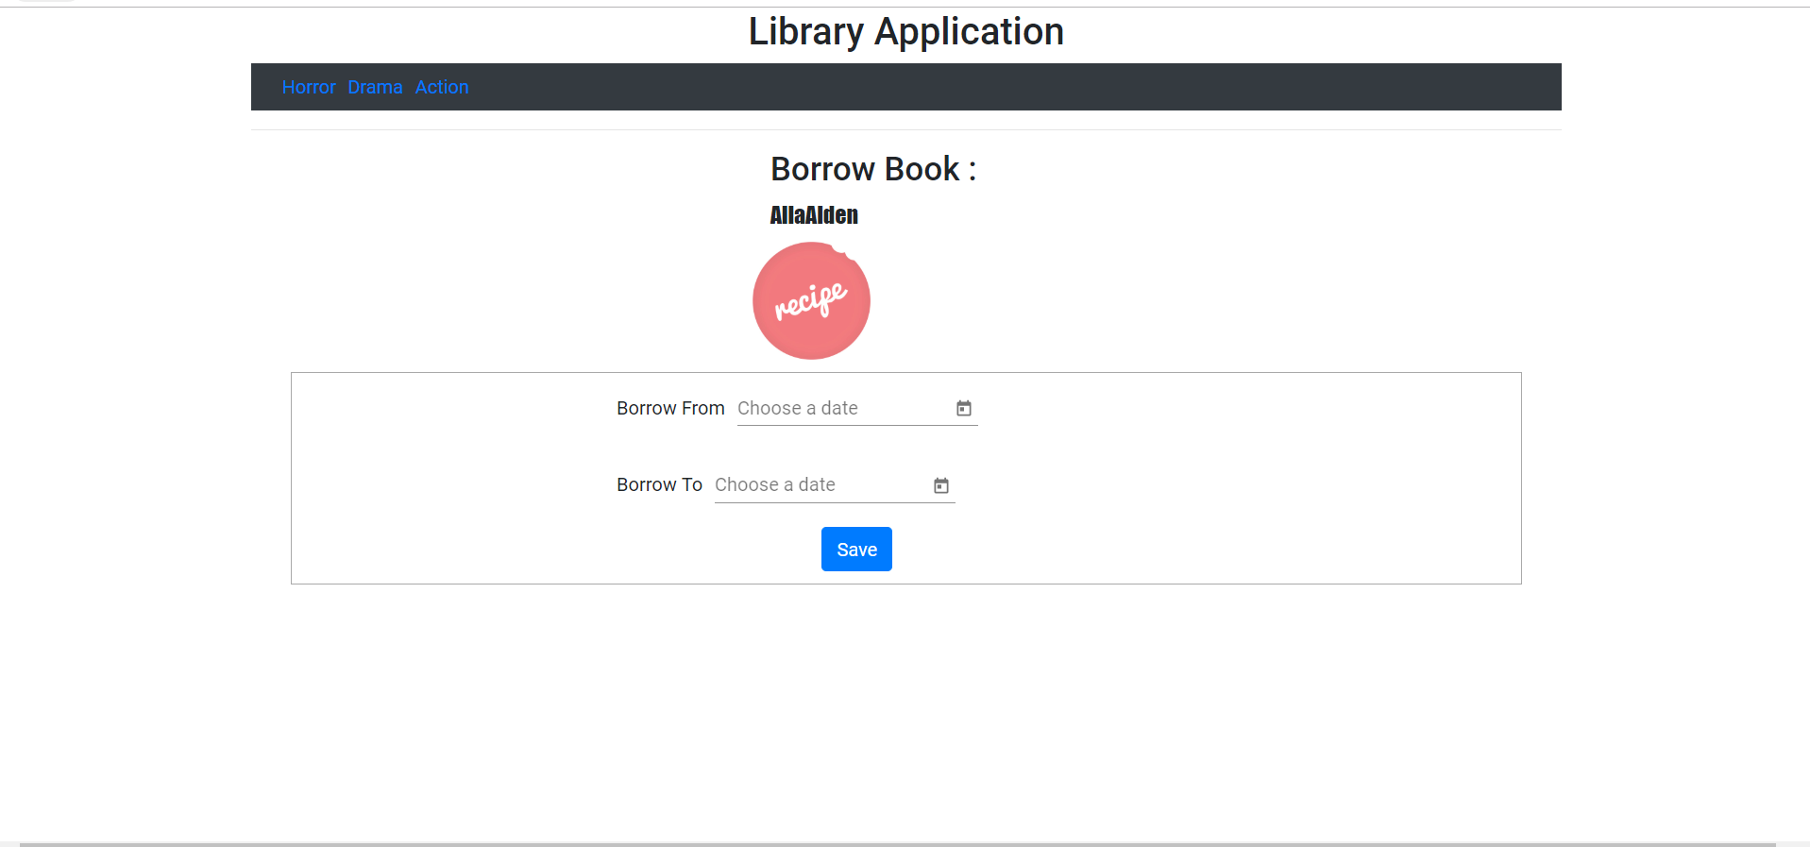

**Click save to add borrow book to the db.**